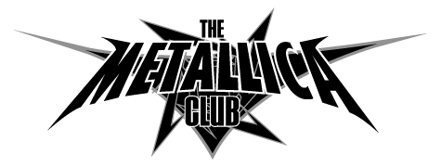
The Metallica Club
PMB # 194
369-B THIRD ST
SAN RAFAEL, CA 94901-3581
FAX 415-458-1752

New Member referred by 10953

NAME:

Last First Middle initial
ADDRESS:

CITY: STATE: ZIP: COUNTRY:

PHONE: EMAIL:

BIRTHDAY: / / Male Female (WE DO NOT SHARE OR SELL PERSONAL INFORMATION)
Month Day Year

Membership Level: (check one box ONLY) See back for details * Please circle T-SHIRT SIZE *
USA Residents Only: Outside USA (Including Canada):
M L XL XXL
US Standard ($25.00 USD) International Standard ($35.00 USD)

US Standard Plus ($35.00 USD) International Premier ($60.00 USD)

US Premier ($45.00 USD)
Please allow 8-10 weeks for delivery
US Premier Plus ($55.00 USD)

PAYMENT TYPE (circle one): CHECK MONEY ORDER CREDIT CARD

I enclose a check or money order number: In the amount of $ .00 (IN USD ONLY)
Please make checks or money orders payable to The Metallica Club. Members, if you choose to pay for your order with a check, you must allow 3 weeks for the check to clear before your order is processed. We accept checks in US dollars from a US bank ONLY. To our friends outside of the USA: We accept checks in US dollars only if your local bank is affiliated with a US bank. We suggest that you contact your local bank for further information about US dollar transactions, otherwise you may want to consider credit card payment. We cannot accept checks in any foreign currencies – sorry. Please do not send cash. Always include payment with your application.
I request that you renew me as a member of The Metallica Club and send my membership package to the address stated above.

Signature Date

CREDIT CARD HOLDER’S DETAILS:
Very Important!
CARD #: EXP: (MM/YEAR)

NAME:

ADDRESS (if different than above): CITY/ST/ZIP:

(BILLING ADDRESS)

AMOUNT: $ .00 (IN U.S. DOLLARS)

I hereby authorize “THE METALLICA CLUB” to charge the above amount to my credit card as detailed above.

SIGNED: DATE:

